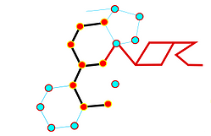

13th meeting of the

European Network for Oxysterol Research

Food Science and Nutrition:
Oxysterols and phytosterols in age-related disease and immune regulation

12th - 13th September 2024 – Leeds, U.K

Conference Venue

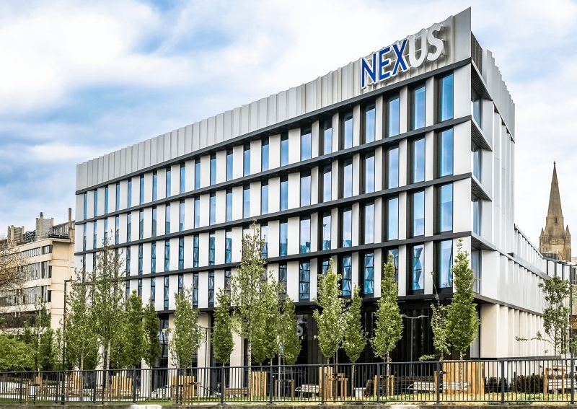

NEXUS conference center, Woodhouse Lane, Leeds, LS2 9JT

Directions to Nexus, the event venue can be found here - https://nexusleeds.co.uk/travelling-to-nexus/

Accommodation

Accommodation is available within walking distance of the venue, here are some examples

Premier Inn Leeds City Centre (Leeds Arena) hotel | £83*
ibis Styles Leeds City Centre Arena | £60*
Radisson Blu Hotel, Leeds City Centre | £100*
(*prices are a guide, please contact the hotels directly)

Sponsors

Organising committee
Dr James L Thorne
Dr Giorgia Cioccoloni
Dr Hanne Røberg-Larsen
Prof Jean-Marc Lobaccaro
Dr Irundika Dias
Ms Jenna King

Scientific committee
Dr James Thorne
Dr Hanne Røberg-Larsen
Prof Jean-Marc Lobaccaro (France)
Prof Luigi Iuliano (Italy)
Prof Gérard Lizard (France)
Prof William J. Griffiths (United Kingdom)
Prof Dieter Lütjohann (Germany)
Prof Marc Poirot (France)
Prof Jogchum Plat (Netherlands)

Programme
Day 1, Thursday 12th September

08:00 Registration, tea and coffee
08:15 Introduction and Welcome
Luigi Iuliano, Gerard Lizard, James Thorne, Giorgia Cioccoloni

Session One: Molecular mechanisms of action of oxysterols and phytosterols
(Chair: James L Thorne)

0830 – 0930 Plenary 1: “The liver x receptor” – Jean-Marc Lobaccaro

Oral communications (15+5) to be selected from submitted abstracts
0930-0950 OC1
0950-1010 OC2
1030-1040 OC3

Flash talks (7+3) to be selected from submitted abstracts
1040-1050 FT1
1050-1100 FT2

1100-1130 Coffee break and poster viewing

Oral communications (15+5) to be selected from submitted abstracts
1130-1150 OC4
1150-1210 OC5
Flash talks (7+3) to be selected from submitted abstracts
1210-1220 FT4
1220-1230 FT5

1230-1355 Lunch and poster viewing

Session Two: Detection and quantification of oxysterols and phytosterols
(Chair: Hanne Røberg-Larsen)

1400 – 1500 Plenary 2: “Imaging sterols” – Prof Ruth Andrews

Oral communications (15+5) to be selected from submitted abstracts
1500-1520 OC6
1520-1540 OC7
1540-1600 OC8
Flash talks (7+3) to be selected from submitted abstracts
1600-1610 FT5
1610-1620 FT6
1620-1630 FT7

1630-1700 Coffee break and poster viewing
1700-1800 ENOR general assembly
1930: Gala Dinner

Day 2, Friday 13th September

0815-0830 Welcome to Day 2

Session three: Oxysterols and Phytosterols in age-related disease
(Chair: Dr Irundika Dias)

0830-0930 Plenary 3: “Phytosterols, LDL-C, and cardiovascular disease risk” Dieter Lütjohann

Oral communications (15+5) to be selected from submitted abstracts
0930-0950 OC9
0950-1010 OC10
1030-1040 OC11

Flash talks (7+3) to be selected from submitted abstracts
1040-1050 FT8
1050-1100 FT9

1100-1130 Coffee and poster viewing

Session four: Oxysterols and Phytosterols in immune function
(Chair: Giorgia Cioccoloni)

Oral communications (15+5) to be selected from submitted abstracts
1130-1150 OC15
1150-1210 OC16
1210-1230 OC17

Flash talks (7+3) to be selected from submitted abstracts
1230-1240 FT12
1240-1250 FT13

1250-1300 Awards
1300-1330 ENOR announcements
1330-1430 Lunch and Close

